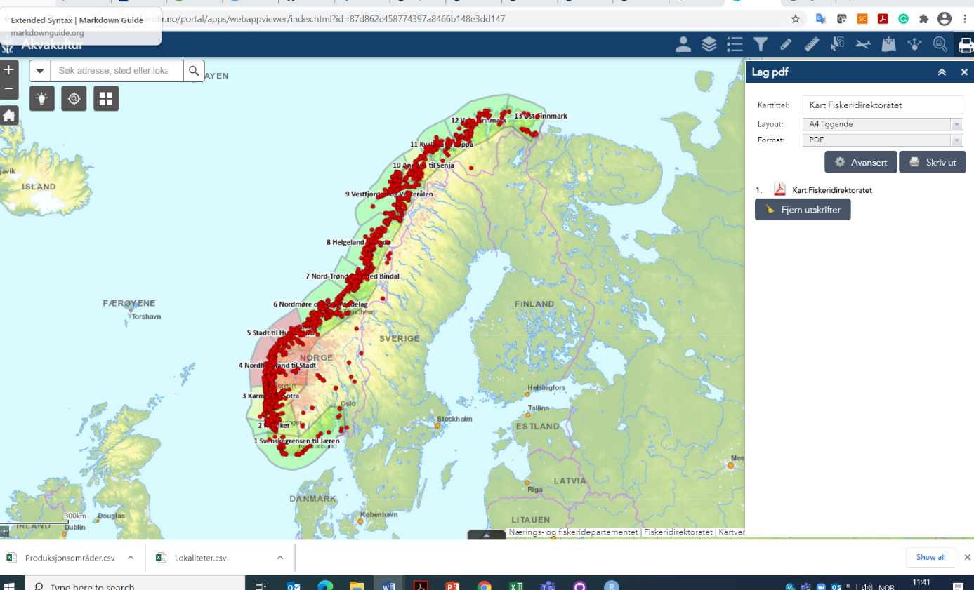

<https://portal.fiskeridir.no/portal/apps/webappviewer/index.html?id=87d862c458774397a8466b148e3dd147>

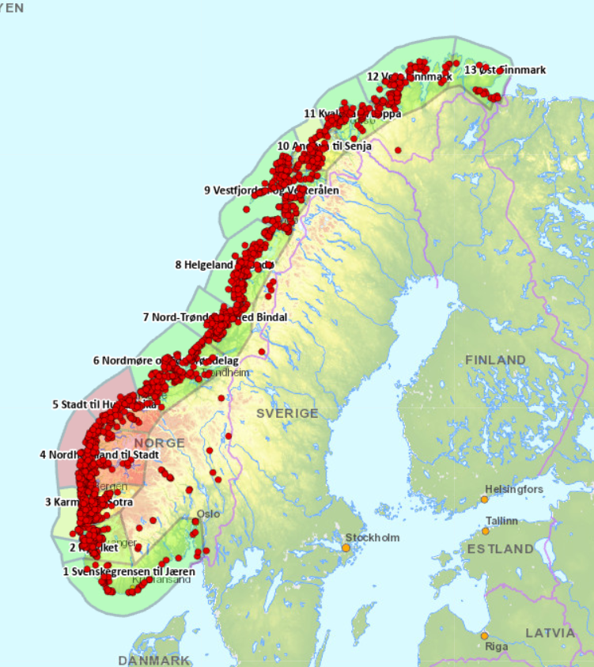

<https://www.barentswatch.no/fiskehelse/>

Code from Kathie

Coastline = read_sf(dsn="//vetinst.no/dfs-felles/Felles02/FAG/EksterneDatakilder/GIS/FormaterteData",  
layer="Hav_norge")  
Norway = read_sf(dsn="//vetinst.no/dfs-felles/Felles02/FAG/EksterneDatakilder/GIS/FormaterteData",  
layer="Norge_N5000")  
Zones = readRDS(here("Data/zones.Rds"))  
Zones$id <- as.character(Zones$id)  
Zones$id[13] <- 13  
Zones$id <- as.factor(Zones$id)  
Zones <-st_as_sf(Zones)  
ILA_df_map = st_as_sf(ILA_df %>%  
filter(!is.na(N_geowgs84), #Remove entries with missing coordinates  
Status == "Påvist")%>%  
dplyr::filter(!Mistanke_dato == "2018-12-20"),  
coords=c("E_geowgs84", "N_geowgs84"), crs=4326) %>%  
dplyr::mutate(Status = factor(Status, levels=c("Påvist", "Mistanke"), labels = c("Case farm", "Suspected"))) %>%  
dplyr::filter(Status == "Case farm") %>%  
dplyr::mutate(Status = "Case farm ")

ISA_palette = c("Case farm " = "#D55E00")

map = tm_shape(Coastline) +  
tm_fill() +  
tm_shape(Norway) +  
tm_borders(lwd=1) +  
tm_shape(Zones) +  
tm_borders(lty = 2) +  
tm_shape(ILA_df_map) +  
tm_symbols(title.col = "ISAV-HPRΔ detected in 2019-2020",  
shape = 21,  
col = "Status",  
palette = ISA_palette,  
size = .2,  
border.col = "black",  
border.lwd = 1) +  
tm_shape(Zones %>% dplyr::filter(id == 1)) +  
tm_text("id",  
ymod = -1.75,  
xmod = -1,  
size = .75,  
fontface = "bold") +  
tm_shape(Zones %>% filter(id == 2)) +  
tm_text("id",  
ymod = -0.2,  
xmod = -1.5,  
size = .75,  
fontface = "bold") +  
tm_shape(Zones %>% filter(id == 3)) +  
tm_text("id",  
ymod = -0.2,  
xmod = -1.2,  
size = .75,  
fontface = "bold") +  
tm_shape(Zones %>% filter(id == 4)) +  
tm_text("id",  
ymod = .75,  
xmod = -1.5,  
size = .75,  
fontface = "bold") +  
tm_shape(Zones %>% filter(id == 5)) +  
tm_text("id",  
ymod = .8,  
xmod = -.8,  
size = .75,  
fontface = "bold") +  
tm_shape(Zones %>% filter(id == 6)) +  
tm_text("id",  
ymod = 1,  
xmod = -.8,  
size = .75,  
fontface = "bold") +  
tm_shape(Zones %>% filter(id == 7)) +  
tm_text("id",  
ymod = .8,  
xmod = -1.2,  
size = .75,  
fontface = "bold") +  
tm_shape(Zones %>% filter(id == 8)) +  
tm_text("id",  
ymod = 0,  
xmod = -1.,  
size = .75,  
fontface = "bold") +  
tm_shape(Zones %>% filter(id == 9)) +  
tm_text("id",  
ymod = 1.,  
xmod = -.7,  
size = .75,  
fontface = "bold") +  
tm_shape(Zones %>% filter(id == 10)) +  
tm_text("id",  
ymod = 1.2,  
xmod = -.5,  
size = .75,  
fontface = "bold") +  
tm_shape(Zones %>% filter(id == 11)) +  
tm_text("id",  
ymod = 1.,  
xmod = -.7,  
size = .75,  
fontface = "bold") +  
tm_shape(Zones %>% filter(id == 12)) +  
tm_text("id",  
ymod = 1.,  
xmod = -.7,  
size = .75,  
fontface = "bold") +  
tm_shape(Zones %>% filter(id == 13)) +  
tm_text("id",  
ymod = 1.5,  
xmod = 0,  
size = .75,  
fontface = "bold") +  
tm_legend(position = c("right", "center"), text.size=1) +  
tm_compass(size=2,  
position=c("left", "top")) +  
tm_scale_bar(breaks = c(0, 100, 200, 300), text.size=.8)

map